
Course Name and Code: Data Structures Lab (1UITL302)
Semester: III (Second Year)
Academic Year: 2023-24 (Odd Semester)
name: parnika gangrade
class: SY A S2

Experiment No. 09

Aim: Implementation of Binary Search Technique considering a real-world application.

Objectives:
1 To impart knowledge of sorting and searching algorithms.

Theory:

Binary search is a highly efficient algorithm used for finding a specific element in a sorted array or list. The primary advantage of binary search over linear search is its speed; while linear search examines each element sequentially, binary search divides the search interval in half with each step, significantly reducing the number of comparisons needed.
Algorithm:
Initialization: Set low to 0 and high to the last index of the array.
- Loop Condition: Continue the loop as long as low is less than or equal to high.
- Midpoint Calculation: Compute the midpoint index.
- Comparison:
- If the middle element equals the target, return the midpoint index.
- If the middle element is less than the target, move the low pointer to mid + 1.
- If the middle element is greater than the target, move the high pointer to mid - 1.
- Completion: If the loop exits without finding the target, return -1 to indicate the target is not present.

Program:

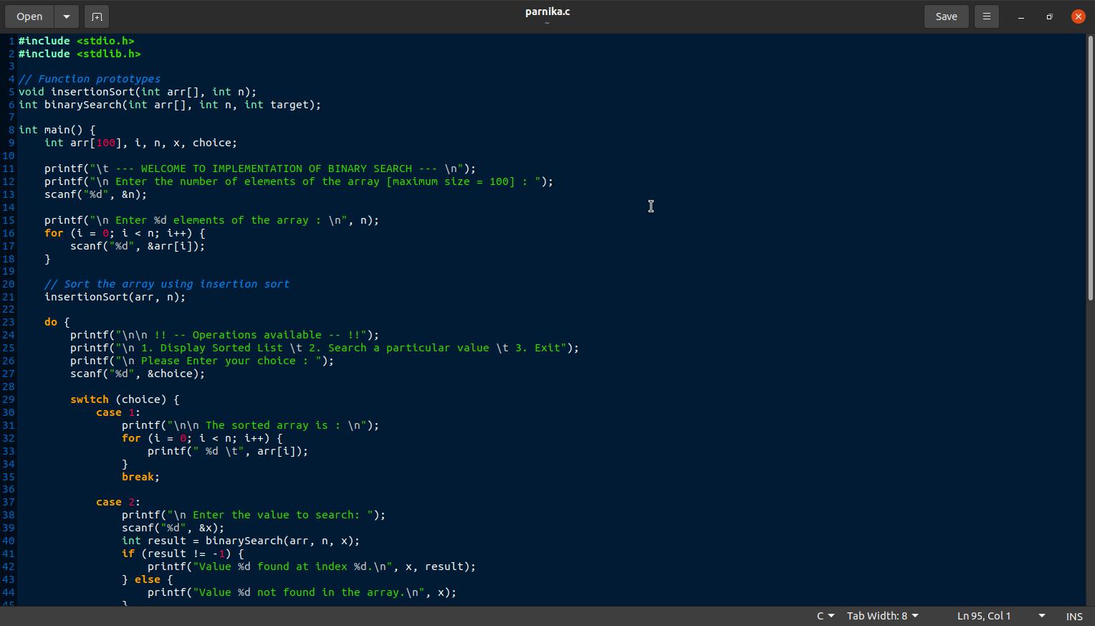

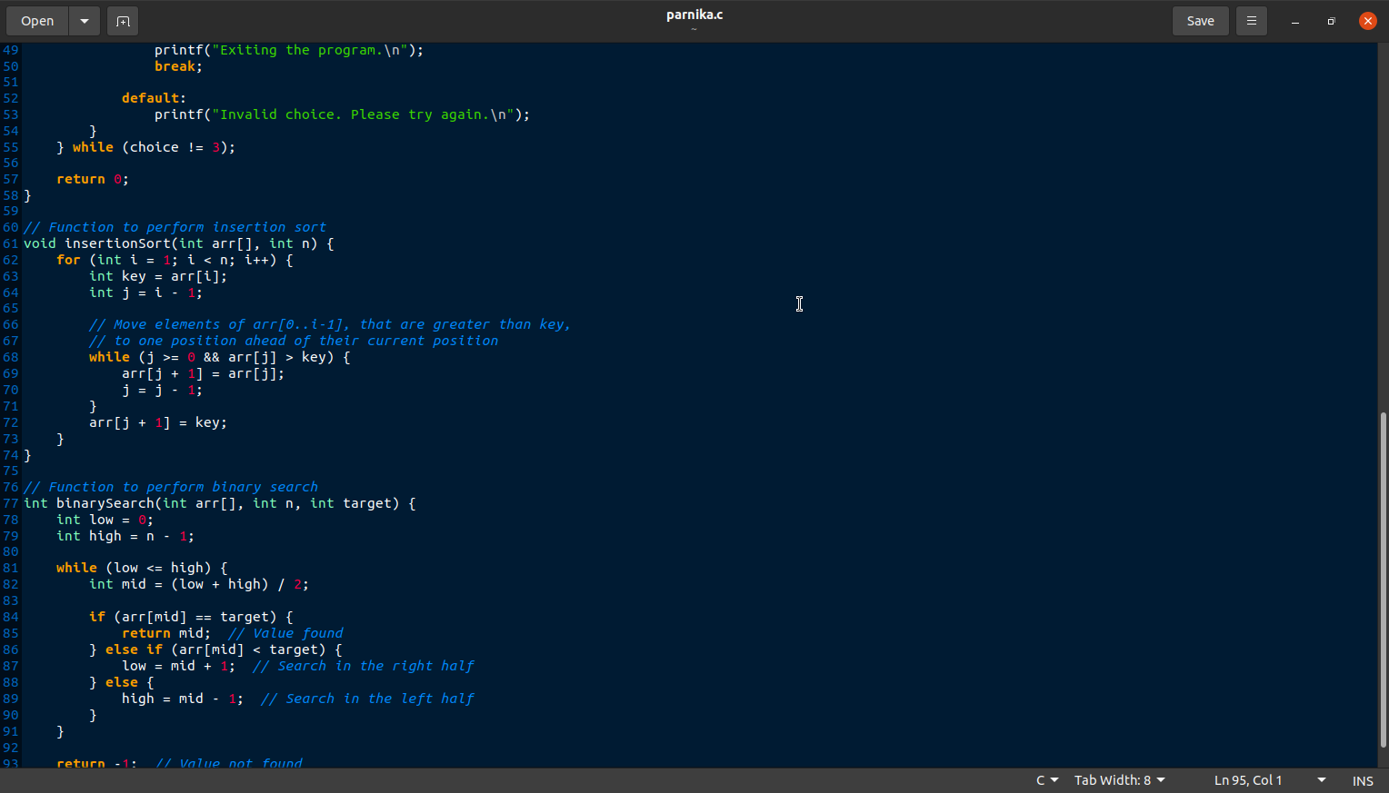

OUTOUT:

